# “END TO END DIABETES PREDICTION SYSTEM”

A PROJECT REPORT

*Submitted by*

**Modi Krushil A. (2021095900003707)**

**Patel Utkarsh S. (2021095900003681)**

**Patel Nisarg R. (2021095900003603)**

*in partial fulfilment for the award of the degree of*

## BACHELOR OF ENGINEERING

*in*

### Computer Engineering/Information Technology

**Sankalchand Patel College of Engineering, Visnagar**

** **

## Sankalchand Patel University, Visnagar

**May 2024**

 

**Sankalchand Patel College of Engineering, Visnagar**

At & Post: Visnagar, Gujarat - *384315*

# CERTIFICATE

This is to certify that the project report submitted along with the project entitled “**END TO END DIABETES PREDICTION SYSTEM**” has been carried out by **Modi Krushil Akshaykumar(2021095900003707)** under my guidance in partial fulfillment for the degree of Bachelor of Engineering in **Computer Engineering**, 8th Semester of Sankalchand Patel University, Visnagar during the academic year 2023-24.

Prof. Jayesh M Mevada Dr. Kirit Modi

Internal Guide Head of the Department

 

**Sankalchand Patel College of Engineering, Visnagar**

At & Post: Visnagar, Gujarat - *384315*

# CERTIFICATE

This is to certify that the project report submitted along with the project entitled “**END TO END DIABETES PREDICTION SYSTEM**” has been carried out by **Patel Utkarsh Sanjaybhai(2021095900003681)** under my guidance in partial fulfillment for the degree of Bachelor of Engineering in **Computer Engineering**, 8th Semester of Sankalchand Patel University, Visnagar during the academic year 2023-24.

Prof. Jayesh M Mevada Dr. Kirit Modi

Internal Guide Head of the Department

 

**Sankalchand Patel College of Engineering, Visnagar**

At & Post: Visnagar, Gujarat - *384315*

# CERTIFICATE

This is to certify that the project report submitted along with the project entitled “**END TO END DIABETES PREDICTION SYSTEM**” has been carried out by **Patel Nisarg Rakeshbhai(2021095900003603)** under my guidance in partial fulfillment for the degree of Bachelor of Engineering in **Computer Engineering**, 8th Semester of Sankalchand Patel University, Visnagar during the academic year 2023-24.

Prof. Jayesh M Mevada Dr. Kirit Modi

Internal Guide Head of the Department

# ACKNOWLEDGMENT

With a sense of gratitude and respect, we would like to extend our heartiest thanks to all those who provided help and guidance in making this project a success. The successful completion of any task is accompanied by a deep emotion of fulfilment and satisfaction. It was a pleasant and highly educative experience throughout the development of the project.

Sincerely, we thank our Head of the Department of College **Dr. Kirit J. Modi**. who gave us the opportunity to undertake such kind of challenging and innovative work and our internal guide **Prof. Jayesh M Mevada** who gave us guidance, help and motivation throughout the entire project. Without Sir’s support, these activities would have been tougher. We are grateful to our guide for the guidance and constructive suggestions that helped us in the preparation of this project.

# ABSTRACT

* Diabetes is one of the chronic diseases that causes blood sugar levels to rise. If diabetes is left untreated and undiagnosed, it can lead to complications. The time-consuming identification process leads to a patient's referral to a diagnostic Centre and consultation with a doctor. Predictive analytics in healthcare is a difficult challenge, but it can eventually assist physicians in making timely decisions about a patient's health and condition based on data. The emergence of machine learning methods solves this crucial issue.
* The aim of this project is to create a model that can reliably predict the accuracy of diabetes in patients. Dataset splits into three then classification techniques are implemented. Training Dataset, Dataset sample that is used to fit the model. Validation Dataset, Dataset sample that is used for hyper tuning the parameters, and comparing the accuracy and error rates of the model performance between using the training dataset and the validation dataset. Testing Dataset, Dataset sample that is used to test the model performance (predictive power).
* To detect diabetes at an early stage, this project employs machine learning classification algorithms:, SVM, Decision tree and Random Forest are implemented. The Pima Indians Diabetes Database (PIDD) is used in the experiments. The National Institute of Diabetes and Digestive and Kidney Diseases provided the results. The dataset's purpose is to diagnose whether a patient has diabetes using diagnostic measures included in the dataset. Various measures like Precision, Accuracy, Specificity, and Recall are measured over classified instances using Confusion Matrix.
* The accuracy of the algorithms used are compared and discussed. The study's comparison of the various machine learning techniques shows which algorithm is better suited for diabetes prediction. Using machine learning methods, this project aims to assist doctors and physicians in the early detection of diabetes

**TABLE OF CONTENTS**

Acknowledgement 3

Abstract 4

Chapter 1 Introduction 5

1.1 Introduction 5

1.2 Objectives 6

1.3 Motivation6

1.4 Overview of the Project 7

1.5 Chapter wise Summary 7

Chapter 2 System Environment 8

2.1 Hardware configuration 8

2.2 Software configuration 8

2.3 Technology 8

2.3.1.1 Python 9

2.3.1.2 Machine Learning 10

2.3.1.3 Flask 11

Chapter 3 data analysis 9

3.1 Structure of Data 9

3.2 Parameters Implemented 11

3.3 Exploratory Data analysis 12

3.4 Histogram 15

3.5 Correlation 16

3.6 SNS Pair plot 17

**Chapter 4 System design 21**

4.1 Use case diagram 21

4.2 UML diagram 21

4.3 Activity diagram 22

4.4 Class diagram 24

4.5 Data flow diagram 25

Chapter 5 Implementation 26

5.1 Hypothesis Testing 26

5.2 Splitting of Dataset 27

5.3 Feature Scaling 28

5.4 Implementing Machine Learning Algorithms 29

5.4.1 Decision Tree Model 31

5.4.2 Random Forest Model 31

5.4. 3 Support Vector Machine Model 31

5.4. 4 Bagging Classifier 32

5.4. 5 Ada Boost Classifier 32

**Chapter 6 Test Results/**

**experiments/verification………………………………………………………………..33**

Testing 33

Comparative Analysis 38

Chapter 7 Snapshorts 39

Screenshot 39

Chapter 8 Conclusions and Further Scope 42

Chapter 9 Reference 43

## INTRODUCTION

**1.1 INTRODUCTION:-**

#### Various classification strategies are used in the medical field for classifying data into different classes. Diabetes is a condition that affects the body's ability to produce the hormone insulin, which causes carbohydrate metabolism to become irregular and blood glucose levels to increase. High blood sugar is a common symptom of diabetes. If diabetes is not treated, it can lead to a variety of complications. Diabetic ketoacidosis and nonketotic hyperosmolar coma are two significant complications. Diabetes is considered a severe health problem in which the amount of sugar in the blood cannot be regulated. Diabetes is influenced by a variety of factors such as height, weight, genetic factors, and insulin, but the most important factor to remember is sugar concentration. The only way to avoid problems is to identify the problem early. This dataset comes from the ‘National Institute of Diabetes and Digestive Diseases’ Pima Indians Diabetes Database (PIDD). Several constraints were taken from the massive database.

* The dataset is divided into three sections, after which classification techniques are used. The training dataset is a sample of the dataset that is used to match the model. Validation Dataset, a dataset sample used for fine-tuning parameters and comparing model output accuracy and error rates between the training and validation datasets. Testing Dataset is a sample of a dataset that is used to assess the model's output.

**1.2 OBJECTIVES:-**

• Since a decade, the number of people diagnosed with diabetes has risen

significantly. The current human lifestyle is the primary cause of diabetes rise.

• Main objective of this project is to analyze the data, and see if it is possible to gleam

any furthe information from the data to determine correlation between parameters and diabetes.

• The second is to attempt to get the best accuracy score using various supervised learning

machine learning algorithms. To find out which algorithm is able to best predict whether a

person has diabetes or not based on this dataset.

• The accuracy of the algorithms used are compared and discussed. The study's comparison of the various machine learning techniques shows which algorithm is better suited for diabetes prediction. Using machine learning methods, this project aims to assist doctors and physicians for predicting whether a person has diabetes or not.

**1.3 MOTIVATION:-**

The current human lifestyle is the primary cause of increasing diabetes. The three types of errors that may occur in today's medical diagnosis method:

1. The false-negative form, in which a patient is diabetic in fact but test results show that he or she does not have diabetes.

2.The false-positive type. In this type, a patient in reality is not a diabetic patient but test reports say that he/she is a diabetic patient.

3. The third type is an unclassifiable type in which a system cannot diagnose a given case. This happens because of insufficient knowledge extraction from past data, a given patient may get predicted in an unclassified type. However, in fact, the patient must predict whether he or she will be diabetic or non-diabetic. Such diagnostic errors can result in unnecessary treatments or no treatments at all when they are needed. To prevent or mitigate the magnitude of such an effect, a machine learning algorithm must be used to build a framework that provides reliable results while reducing human effort.

**1.4 OVERVIEW OF PROJECT:-**

* Machine learning has the great ability to revolutionize the diabetes risk prediction with the help of advanced computational methods and availability of a large amount of epidemiological and genetic diabetes risk dataset. Detection of diabetes in its early stages is the key for treatment. This work has described a machine learning approach to predicting diabetes or not. The technique may also help researchers to develop an accurate and effective tool that will reach at the table of clinicians to help them make better decisions about disease status.

**1.5 CHAPTERWISE SUMMARY:-**

* The first chapter is an introductory chapter, which gives an overview of the project. It includes four divisions - introduction, objectives, motivation, overview and chapter wise summary. The second chapter is data analysis, where the dataset is analyzed and studied for further classifications. Third chapter deals with the different machine learning models used. To detect diabetes at an early stage, this project employs machine learning classification algorithms: SVM, Decision tree and Random Forest tree are implemented. The last chapter gives an elaborate idea about the results of different models. Let’s get to know more about

the dataset in the upcoming chapter. .

## SYSTEM ENVIRONMENT

### 

**2.1 HARDWARE CONFIGURATION**

1. Pentium IV Processor

2. 4 GB RAM

3. 40GB HDD

4. 1024*768 Resolution colour Monitor

**Note: This is not the “System Requirements”.**

**2.2 SOFTWARE** **CONFIGURATION**

1. OS: Windows 7 OR More
2. Vs code - 1.88
3. Terminal - 1.19.10821.0

**2.3 Technology**

* Python 3.6 & related libraries
* Machine Learning
* Flask 3.0.2
* Html 5 & CSS 3

**2.3.1.1 Python**

Python is a high-level, interpreted programming language known for its simplicity and readability. It was created by Guido van Rossum and first released in 1991. Python emphasizes code readability and a syntax that allows programmers to express concepts in fewer lines of code compared to languages like C++ or Java.

Key features of Python include:

1. Simple and Easy to Learn: Python's syntax is straightforward and easy to understand, making it an ideal language for beginners. Its readability reduces the cost of program maintenance and development.

2. Interpreted: Python code is executed line by line by the Python interpreter, which means you don't need to compile your code before running it. This makes developmentfaster and more interactive.

3. High-level Language: Python abstracts many complex programming concepts, allowing developers to focus more on solving problems rather than worrying aboutlow-level details.

4. Dynamic Typing: Python is dynamically typed, meaning you don't need to specify the data type of variables explicitly. This feature simplifies coding and makes the language flexible.

5. Rich Standard Library: Python comes with a vast standard library that provides modules and functions for various tasks, such as file I/O, networking, web development, and more. This extensive library reduces the need for external dependencies in many cases.

6. Cross-platform: Python is available on multiple platforms, including Windows, macOS, and various Unix-based operating systems, making it highly portable.

7. Community Support: Python has a large and active community of developers who contribute to its growth. This community provides libraries, frameworks, and resources to extend Python's capabilities.

**Usage**

Python is a versatile programming language with a wide range of applications across various domains. Some of the common uses of Python include:

1.Web Development: Python is widely used for web development, both on the server-side and client-side. Frameworks like Django, Flask, and Pyramid are popular choices for building robust web applications and APIs.

2.Data Science and Machine Learning: Python is the preferred language for data science, machine learning, and artificial intelligence (AI) projects. Libraries like NumPy, Pandas, Matplotlib, scikit-learn, TensorFlow, and PyTorch provide powerful tools for data analysis, visualization, and building machine learning models.

3. Automation and Scripting: Python is excellent for automating repetitive tasks and writing scripts for various purposes. It's commonly used for system administration, file manipulation, web scraping, and task scheduling.

4.cientific Computing: Python is widely used in scientific computing and computational science for numerical simulations, data analysis, and visualization. Libraries like SciPy and SymPy provide tools for scientific computing, while Jupyter Notebook is popular for interactive computing and data exploration.

5. Game Development: Python is used in game development, both for creating games from scratch and for scripting game engines like Unity and Godot. Libraries like Pygame provide tools for developing 2D games, while Panda3D and Pyglet are used for 3D game development.

6.Desktop GUI Applications: Python can be used to develop desktop graphical user interface (GUI) applications using libraries like Tkinter, PyQt, and wxPython. These libraries provide tools for creating windows, buttons,menus, and other GUI components.

7. Web Scraping: Python's simplicity and powerful libraries like BeautifulSoup and Scrapy make it an excellent choice for web scraping tasks. Developers use Python to extract data from websites and APIs for various purposes, such as data collection, market research, and content aggregation.

**2.3.1.2 Machine Learning**

Machine learning (ML) is a subset of artificial intelligence (AI) that focuses on the development of algorithms and models that allow computers to learn from and make predictions or decisions based on data, without being explicitly programmed to perform specific tasks. In Python, machine learning is facilitated by various libraries and frameworks that provide tools for building, training, and deploying machine learning models.

1. Data Preparation: Machine learning models require data to learn patterns and make predictions. Python offers libraries like NumPy, Pandas, and scikit-learn to load, preprocess, and manipulate datasets. These libraries provide functions for tasks such as data cleaning, feature engineering, and data splitting.

2. Choosing a Mode: Python provides a wide range of machine learning algorithms and models through libraries like scikit-learn, TensorFlow, and PyTorch. Depending on the nature of the problem (e.g., classification, regression, clustering), developers can choose the appropriate algorithm to train their model.

3. Training the Model: Once the dataset and model are prepared, developers can train the model using the training data. During the training process, the model adjusts its parameters to minimize the difference between its predictions and the actual target values. Python libraries like scikit-learn provide simple interfaces for training models with just a few lines of code.

4. Evaluation: After training the model, it's essential to evaluate its performance to assess how well it generalizes to new, unseen data. Python libraries offer functions for calculating various metrics such as accuracy, precision, recall, and F1-score for classification tasks, as well as mean squared error, mean absolute error, and R-squared for regression tasks.

5. Hyperparameter Tuning: Many machine learning algorithms have parameters that need to be tuned to achieve optimal performance. Python libraries like scikit-learn provide tools for hyperparameter tuning, such as GridSearchCV and RandomizedSearchCV, which automatically search through a specified set of hyperparameters to find the best combination.

6. Deployment: Once the model is trained and evaluated, it can be deployed into production environments to make predictions on new data. Python libraries like Flask and Django are commonly used for building web services and APIs to serve machine learning models.

**2.3.1.3 Flask**

Flask is a lightweight and flexible web framework for Python. It's designed to make it easy to build web applications quickly and with minimal boilerplate code. Flask is known for its simplicity, ease of use, and extensibility, making it a popular choice among developers for building web applications, APIs, and microservices.

Key features of Flask include:

1.Minimalistic: Flask is minimalist by design, providing only the essential components needed for

web development. This simplicity makes it easy to understand and use, especially for beginners.

2.Flexible: Flask allows developers to structure their applications as they see fit. It doesn't impose any rigid patterns or conventions, giving developers the freedom to organize their code in a way that suits their project.

3.Extensibl: Flask is highly extensible, with a rich ecosystem of extensions that add additional functionality to the framework. These extensions cover a wide range of features such as database integration, authentication, form validation, and more.

4.inja2 Templating: Flask uses the Jinja2 templating engine, which allows developers to build dynamic HTML pages by embedding Python code directly into HTML templates. This makes it easy to generate HTML content dynamically based on data from the application.

5.Built-in Development Serve: Flask comes with a built-in development server, making it easy to get started with web development without the need for additional setup. The development server is suitable for testing and debugging applications during development.

6.RESTful Support: Flask provides built-in support for building RESTful APIs, allowing developers to create web services for serving JSON data to client applications.

7.Werkzeug Integration: Flask is built on top of the Werkzeug WSGI toolkit, which provides low-level utilities for handling HTTP requests and responses. This integration allows Flask to handle HTTP routing, request parsing, and response generation efficiently.

8.Lightweight: Flask has minimal dependencies and a small codebase, making it lightweight and fast. This makes it suitable for building small to medium-sized web applications and APIs.



## DATA ANALYSIS

**3.1 STRUCTURE OF DATA :**

* The dataset is originally from the National Institute of Diabetes and Digestive and Kidney Diseases. The objective of the dataset is to diagnostically predict whether or not a patient has diabetes, based on certain diagnostic measurements included in the dataset. Several constraints were placed on the selection of these instances from a larger database. In particular, all patients here are females at least 21 years old of Pima Indian heritage. The datasets consist of several medical predictor variables and one target variable, Outcome. Predictor variables include the number of patient has, their BMI, insulin level, age etc.

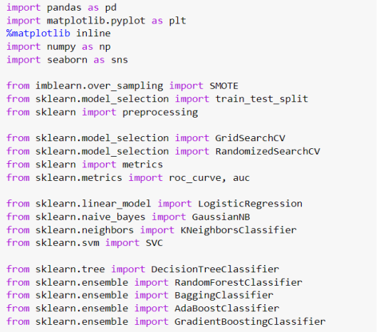

**Fig3.1.1 Importing Libraries**

Fig3.1.1, Importing libraries to implement various machine learning for classification techniques.

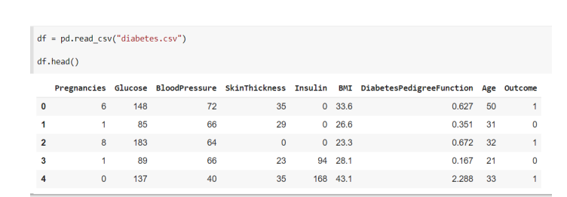

**Fig3.1.2 Loading Dataset**

**Fig3.1.2,** Loading the dataset to understand data structure.

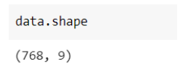

**Fig 3.1.3 Shape of dataset**

Fig 3.1.3, represent total number of rows and columns in Dataset

**3.2 PARAMETERS IMPLEMENTED:-**

* Glucose: Plasma glucose concentration for 2 hours in an oral glucose tolerance test.
* Blood Pressure: Diastolic blood pressure (mm Hg). It is the bottom number in blood pressure tests, and is the pressure in the arteries when the heart rests between beats. A normal diastolic blood pressure is < 80 mm HG.
* Skin Thickness: Triceps skin fold thickness (mm). Studies have been conducted, with conclusions that there are associations between people with thicker skin and diabetes.
* Insulin: 2-Hour serum insulin (mu U/ml). Insulin is a hormone made by the pancreas that allows your body to use sugar (glucose) from carbohydrates in the food that you eat for energy or to store glucose for future use. A high insulin level is associated with diabetes.
* BMI: Body mass index (weight in kg/ (height in m) ^2)
* Range of BMI: BMI < 18.5 - underweight
* 18.5 < BMI < 24.9 - ideal weight
* 25 < BMI < 29.9 – overweight
* 29.9 < BMI - obese
* Diabetes Pedigree Function: It is a synthesis of the diabetes mellitus history in relatives and the genetic relationship of those relatives to the subject.
* Results show that a person with a higher pedigree function tested positive and those who had a lower pedigree function tested negative.
* Age: Age of the patient in years
* Outcome: The target column which we are interested in finding out. 1 - diabetic, 0 - non-diabetic.

**3.3 EXPLORATORY DATA ANALYSIS:-**



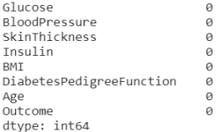

**Fig3.3.1 Exploratory Data Analysis**

Fig 3.3.1, is analyzing the dataset and checking any missing values.



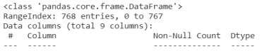

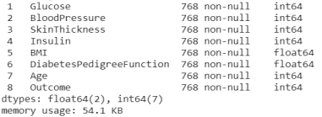

**Fig 3.3.2 Dataset Information**

Fig 3.3.2 Dataset information's are checked.



 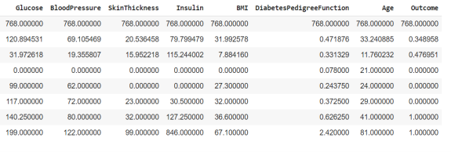

**Fig 3.3.3 Calculating Mean, Count, Min, Max and Standard Deviation.**

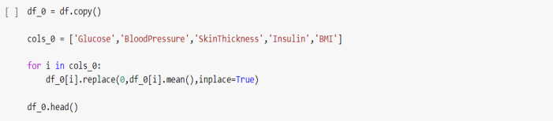

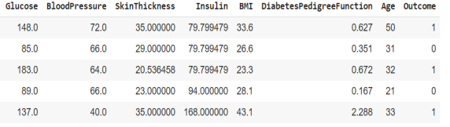

**Fig 3.3.4 Based on the understanding of the parameters, it seems highly**

**unlikely that glucose, blood pressure, skin thickness, insulin and BMI**

**levels are 0.**



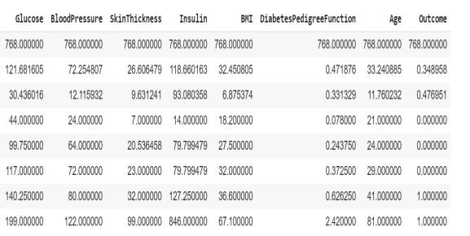

**Fig 3.3.5 Creating a copy of the original dataset and replace the 0 values of the impacted columns with the mean values Now that the 0 values are accounted for, we can proceed with the rest of the Exploratory Data Analysis.**

**3.4 HISTOGRAM PLOT OF DATA :-**

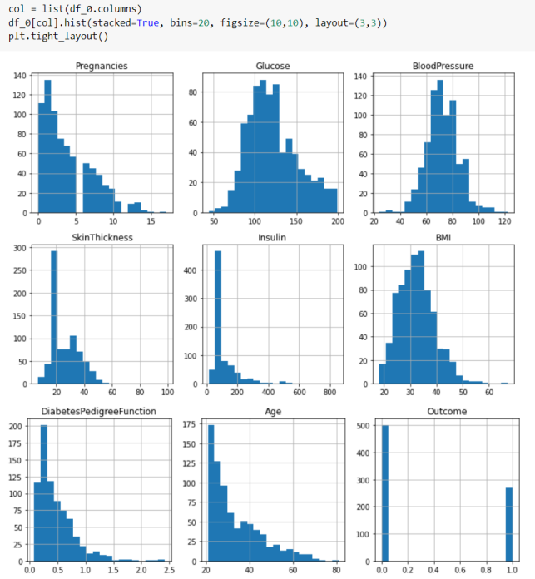

**Fig 3.4.1 Histogram**

The above histogram plots give a high-level view of the bucket distribution of the dataset parameters. At first glance, most of them appear to be positively skewed, with Glucose and Blood Pressure with the closest distribution to a normal distribution. Outcome is a bimoda

**3.5 CORRELATION OF DATA:-**

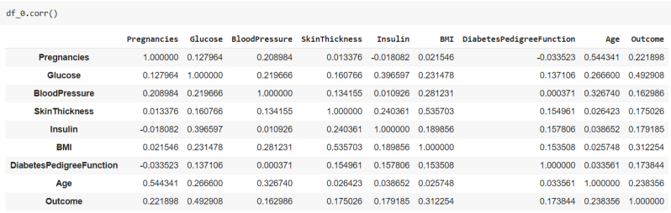

**Fig 3.5.1 Correlation of Data**

The parameter with the highest positive correlation to each other is BMI and Skin Thickness. This is further confirmed by the SNS pair plot. The rest do not have strong multi-collinearity to each other.

**3.6 SNS PAIR PLOT:-**

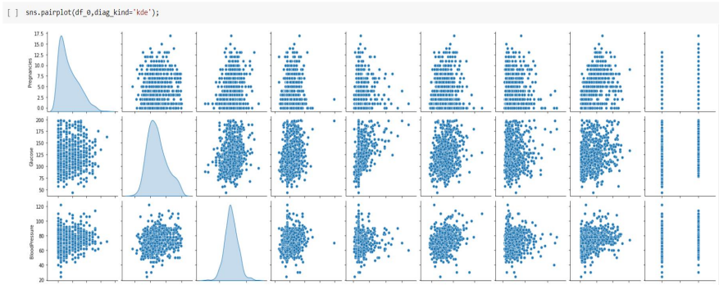

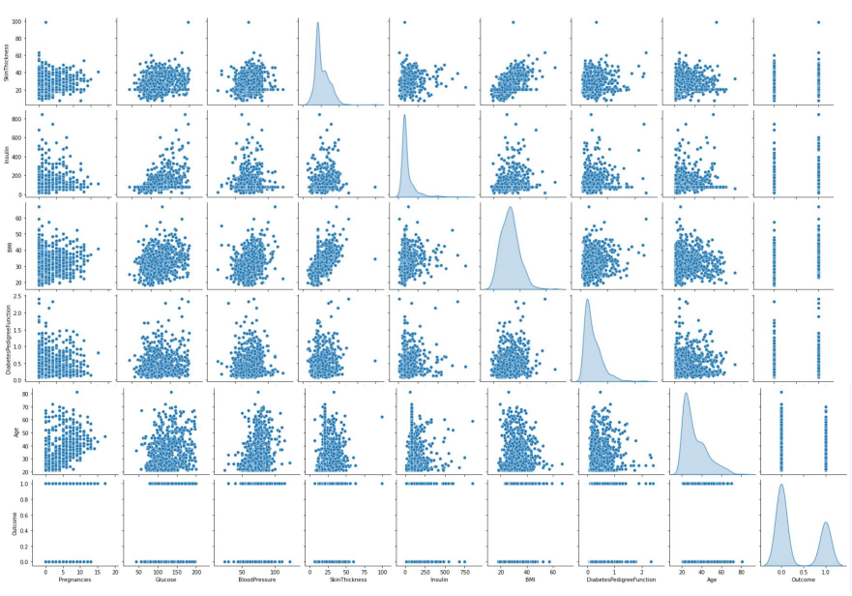

**Fig 3.6.1 SNS Pair plot**

From the plots, we can see that in histogram plot distribution, that most of the parameters are positively skewed, with outcome having a bimodal distribution, which is to be expected. Glucose and Blood Pressure are the only parameters which most resemble a normal distribution. Plot a pair plot to see which parameters might have a stronger correlation with either outcomes of diabetic patient and non-diabetic patient.

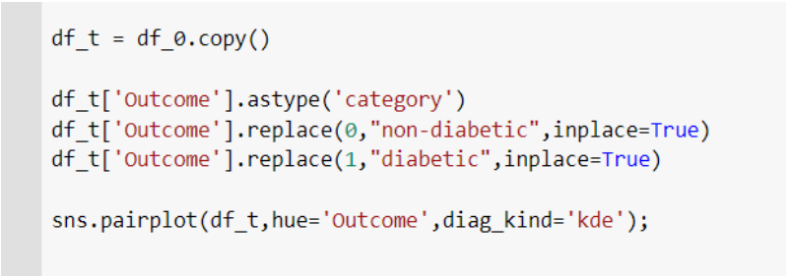

**4.SYSTEM DESIGN**

**USE CASE DIAGRAM:**

* + - Use Case Diagram Displays the relationship among actors and use cases.
    - A use case diagram shows a set of use cases and actors (a special kind of class) and their relationships.
    - Use case diagrams address the static use case view of a system.
    - These diagrams are especially important in organizing

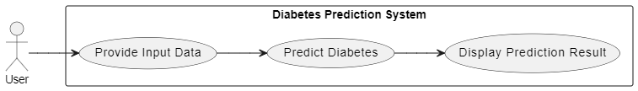

Fig 4.1 Use Case Diagram

**UML DIAGRAM:**

The Unified Language (UML) is a standard language for writing software blueprints. The UML may be used to visualize, specify, construct, and document the artifacts of a software intensive system. **The UML is a** language

Visualizing

* Specifying
* Constructing
* Documenting

A language provides a vocabulary and the rules for combining words in that vocabulary for the purpose of communication. A modeling language is a language whose vocabulary and rules focus on the conceptual and physical representation of a system. A modeling language such as the UML is thus a standard language for software blueprints.

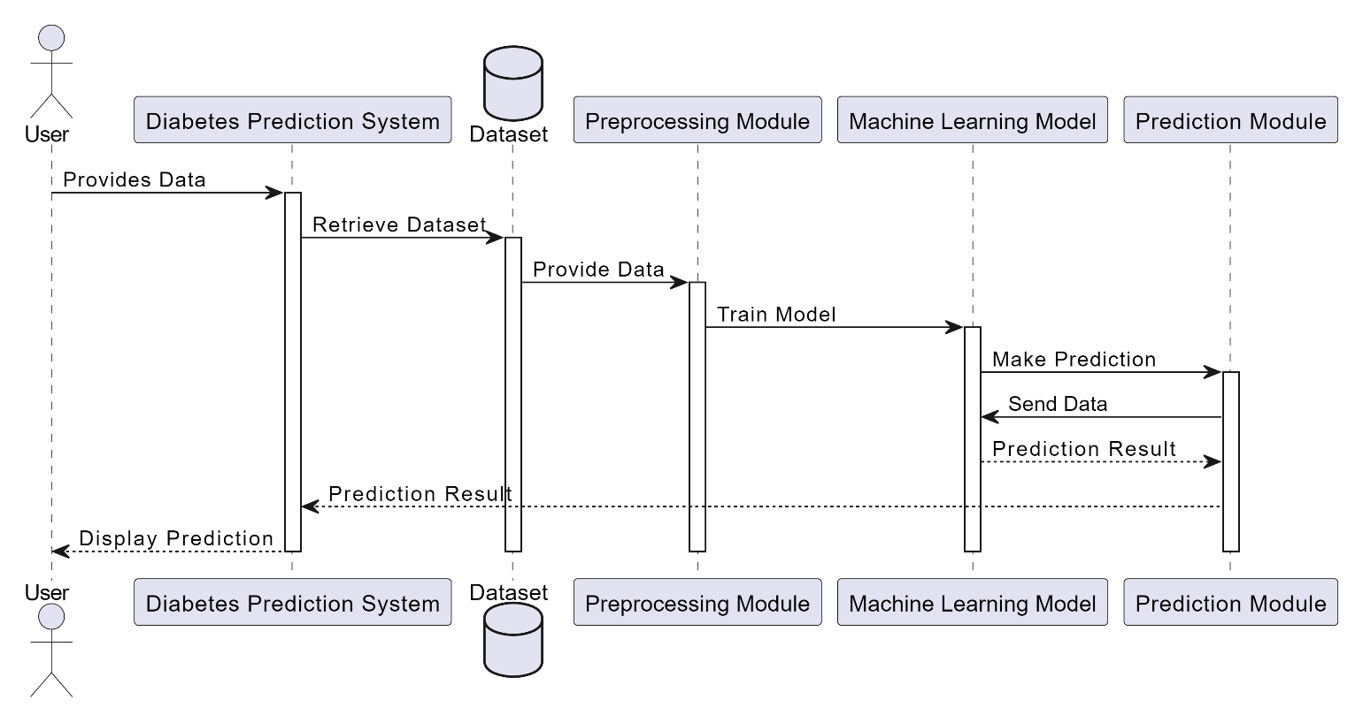

Fig 4.2 UML diagram

**Activity diagram:**

Activity diagrams are one of the five diagrams in the UML for modeling the dynamic aspects of systems. An activity diagram is essentially a flowchart, showing flow of control from activity to activity. You use activity diagrams to model the dynamic aspects of a system. For the most part, this involves modeling the sequential (and possibly concurrent) steps in a computational process. With an activity diagram, you can also model the flow of an object as it moves from state to state at different points in the f low of control. Activity diagrams may stand alone to visualize, specify, construct, and document the dynamics of a society of objects, or they may be used to model the f low of control of an operation. Whereas interaction diagrams emphasize the flow of control from object to object, activity diagrams emphasize the flow of control from activity to activity.

An activity is an ongoing non atomic execution within a state machine. Activities ultimately result in some action, which is made up of executable atomic computations those results in a change in state of the system or the return of a value. Activity diagrams are not only important for modeling the dynamic aspects of a system, but also for constructing executable systems through forward and reverse engineering.

Action states and activity states are just special kinds of states in a state machine. When you enter an action or activity state, you simply perform the action or the activity; when you finish, control passes to the next action or activity. Activity states are somewhat of shorthand, therefore. An activity state is semantically equivalent to Expanding its activity graph (and transitively so) in place until you only see actions. Nonetheless, activity states are important because they help you break complex computations into parts, in the same manner as you use operations to group and reuse expressions.

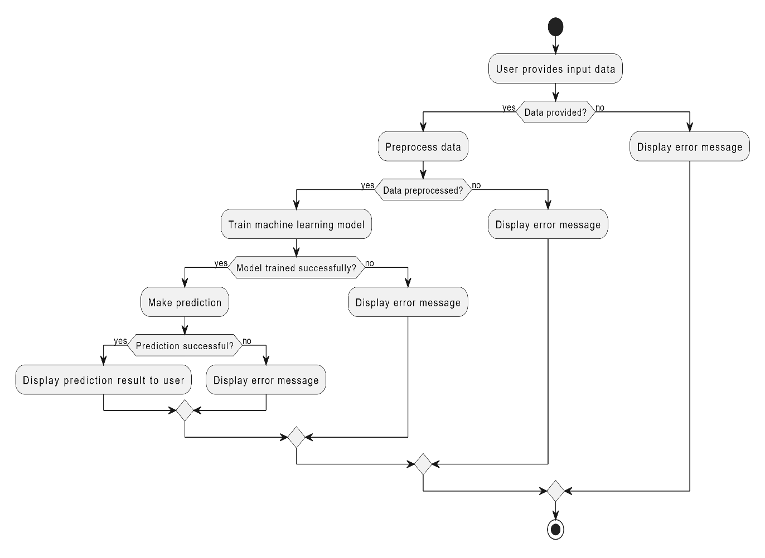

Fig 4.3 Activity Diagram

**Class diagram:**

A class diagram shows a set of classes, interfaces, and collaborations and their relationships. These diagrams are the most common diagram found in modeling object - oriented systems. Class diagrams address the static design view of a system. Class diagrams that include active classes address the static process view of a system. Class diagrams are the most common diagram found in modeling object- oriented systems. A class diagram shows a set of classes, interfaces, and collaborations and their relationships. You use class diagrams to model the static design view of a system. For the most part, this involves modeling the vocabulary of the system, modeling collaborations, or modeling schemas. Class diagrams are also the foundation for a couple of related diagrams: component diagrams and deployment diagrams. Class diagrams are important not only for visualizing, specifying, and documenting structural models, but also for constructing executable systems through forward and reverse engineering. Class diagrams commonly contain the following things:

* Classes
* Interfaces
* Collaborations
* Dependency, generalization, and associationrelationships

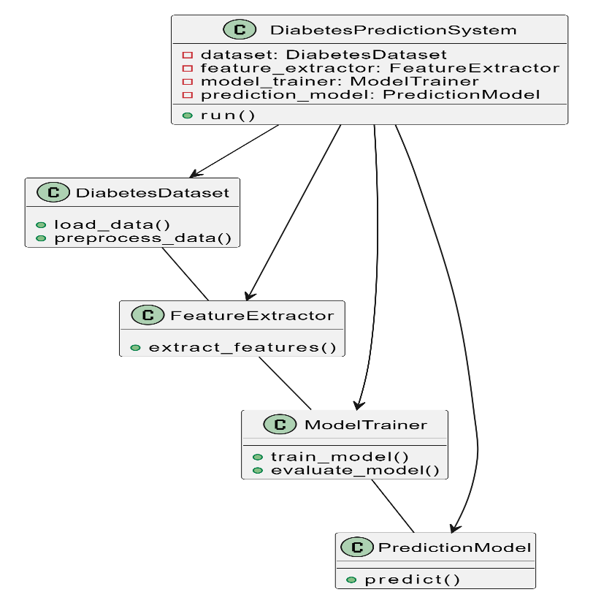

Fig 4.4 Class-Diagram

**Data flow diagram:**

A Data Flow Diagram (DFD) is a graphical representation of the "flow" of data through an Information System. A data flow diagram can also be used for the visualization of Data Processing.

It is common practice for a designer to draw a context-level DFD first which shows the interaction between the system and outside entities. This context-level DFD is then "exploded" to show more detail of the system being modeled.

A DFD represents flow of data through a system. Data flow diagrams are commonly used during problem analysis. It views a system as a function that transforms the input into desired output. A DFD shows movement of data through the different transformations or processes in the system.

Dataflow diagrams can be used to provide the end user with a physical idea of where the data they input ultimately has an effect upon the structure of the whole system from order to dispatch to restock how any system is developed can be determined through a dataflow diagram. The appropriate register saved in database and maintained by appropriate authorizes.

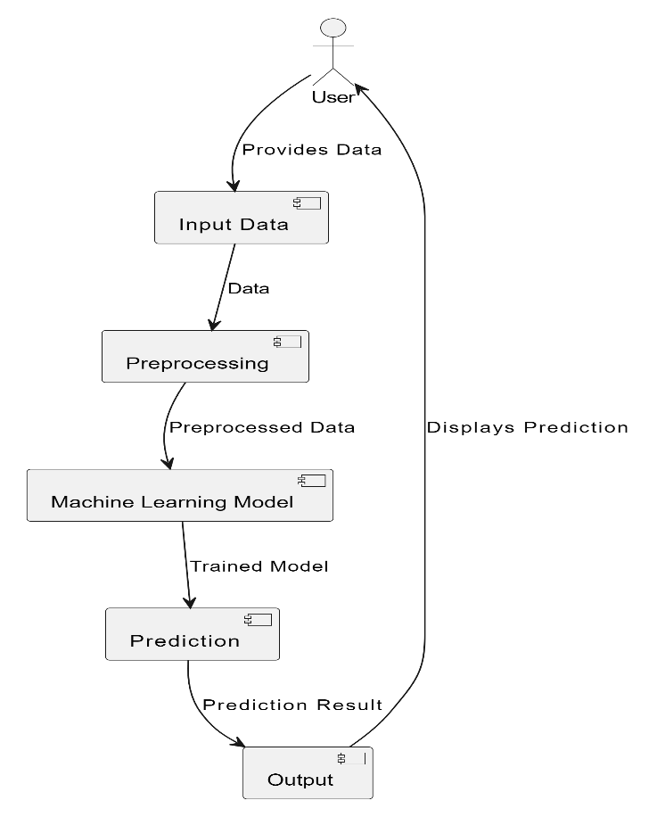

Fig 4.6 Data Flow Diagram

**5.IMPLEMENTATION**

**5.1 HYPOTHESIS TESTING :-**

* First hypothesis test would be to try and confirm my suspicion if Glucose data has a normal distribution.
* Next hypothesis test would be that based on the above hypothesis test, I would test the correlation between Glucose and the target outcome.

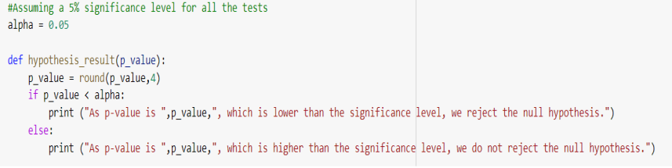

**Fig** **5.1.1 Hypothesis Testing**

* First Hypothesis Test
* Null Hypothesis: The sample comes from a normal distribution. Alternative Hypothesis: The sample does not come from a normal distribution.

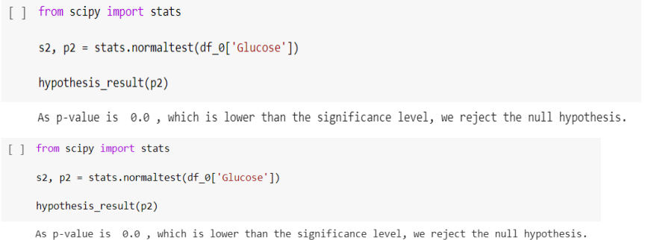

**5.2 SPLITTING OF DATASET (TRAINING/VAILDATION/TESTING):-**

* The splitting of the dataset for validation and testing. Training Dataset: Dataset sample that is used to fit the model. Validation Dataset: Dataset sample that is used for hyper tuning the parameters, and comparing the accuracy and error rates of the model performance between using the training dataset and the validation dataset. Testing Dataset: Dataset sample that is used to test the model performance (predictive power).

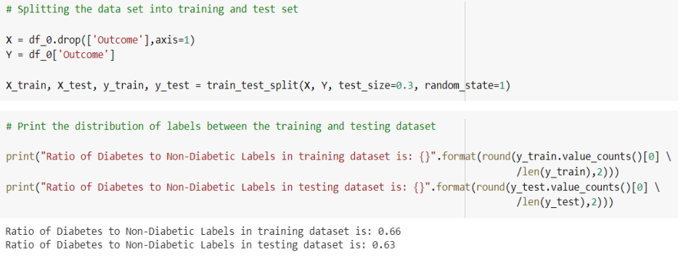

**5.3 Feature Scaling:-**

* Here StandardScaler() is used to perform feature scaling. This will retain the mean and the standard deviation of the sample distribution of the data set, and reuse it to transform the X_train and X_test subsequently. I try to reuse the mean and standard deviation obtained from the training set and apply it to the testing set as well. Standardizing data after data splitting is to prevent data leakage from test dataset into train dataset.

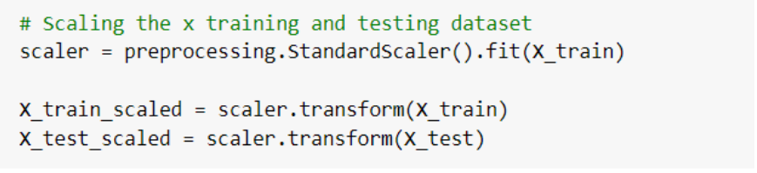

**5.4 Implementing Machine Learning Algorithms:-**

* Different machine learning algorithms to try and classify the pima Indian diabetes dataset. First a confusion matrix function is formed.

1. Accuracy: (TP+TN)/All
2. Recall: TP/(TP+FN)
3. Precision: TP/(TP+FP)
4. Specificity:TN/(TN+FP)

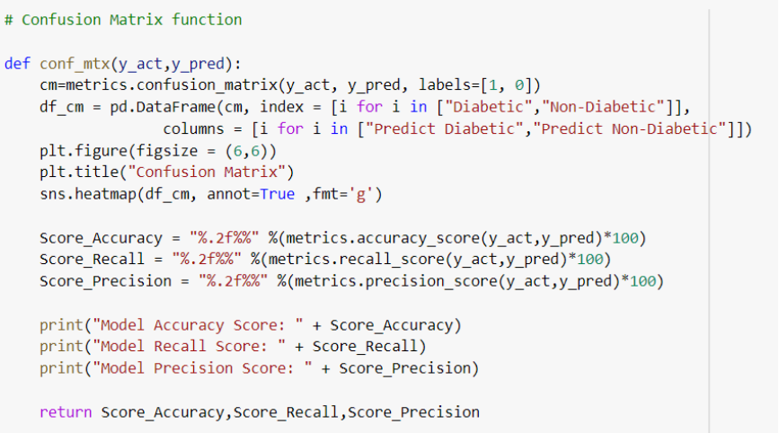



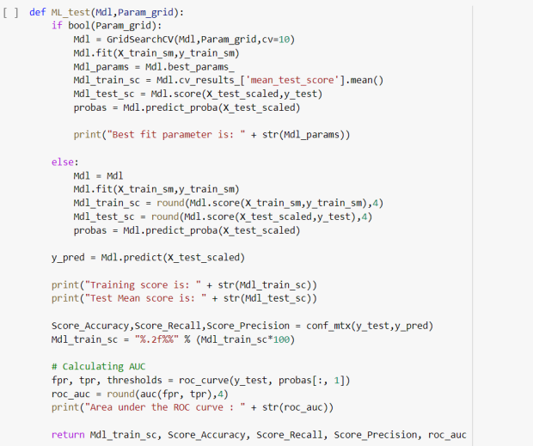

**Fig5.4.0 Building a function for performing ML algos testing**

**5.4.1 Support Vector Machine Model:-**

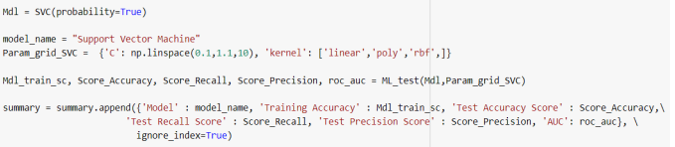

**Fig 4.4.4.1 Support Vector Machine Code**

**5.4.2 Decision Tree Model:-**

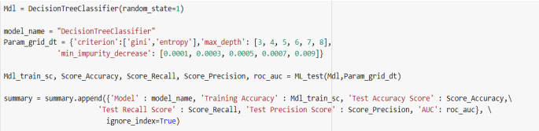

**Fig 4.4.2.1 Decision Tree Code**

**5.4.3 Random Forest Model**

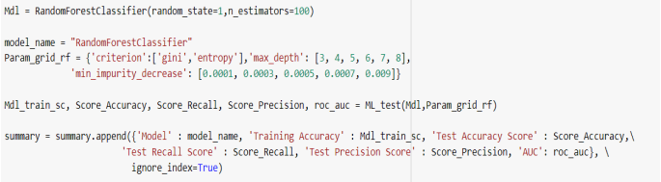

**Fig 5.4.3 Random Forest Code**

**5.4.4 Bagging Classifier :-**

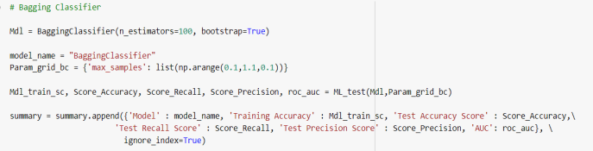

**Fig 5.4.4 Bagging Classifier Code**

**5.4.5 AdaBoost Classifier** :-

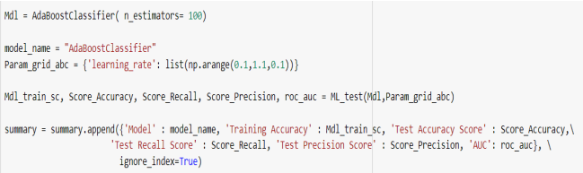

**Fig 5.4.5Ada Boost Classifier Code**

**5. TEST RESULTS**

**5.1 RESULTS :-**

**5.1.1 Support Vector Machine Model :-**

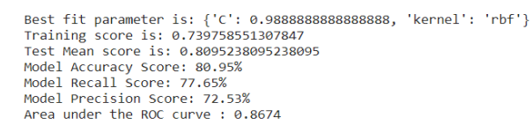

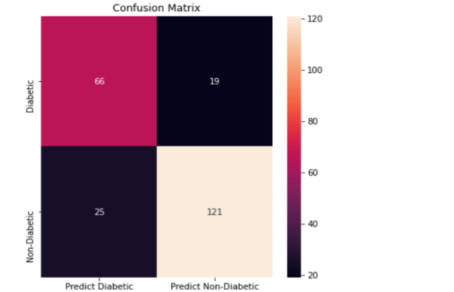

**Fig 5.1.1**

**5.1.2 Decision Tree Model:-**

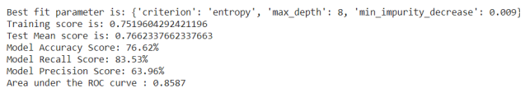

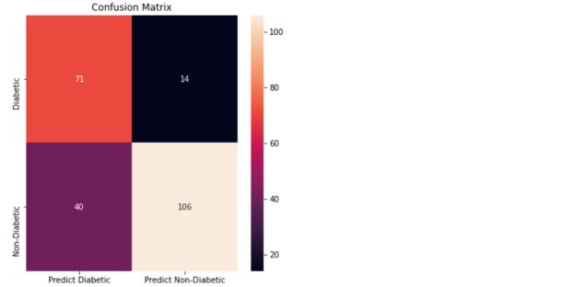

**Fig 5.1.2**

**5.1.3 Random Forest Model:-**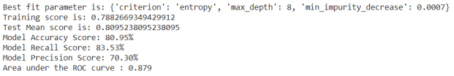

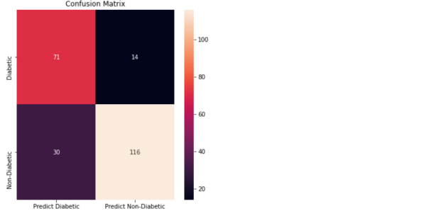

**Fig 5.1.3**

**5.1.4 Bagging Classifier:-**

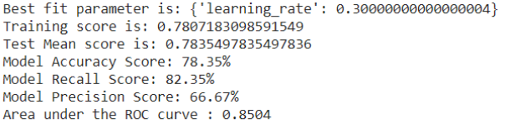

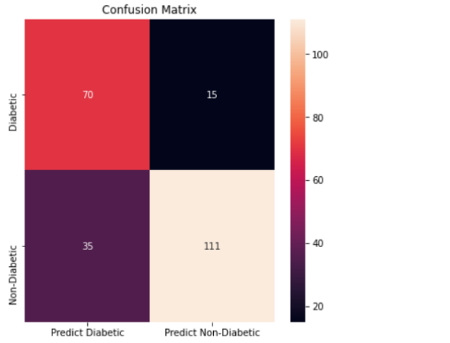

**Fig 5.1.4**

**5.1.5 AdaBoost Classifier:-**

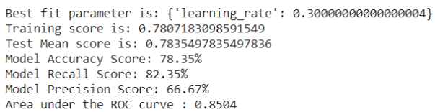

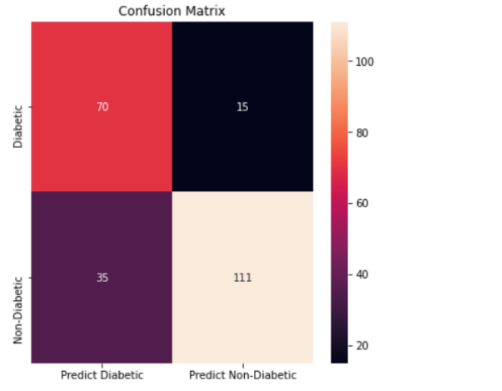

**Fig 5.1.5**

**5.2 COMPARATIVE ANALYSIS:-**

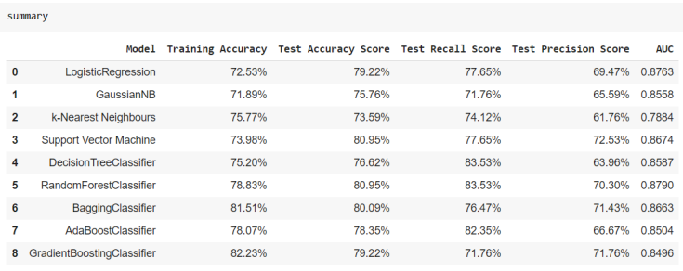

**Table 5.2.1 Comparative Analysis Table**

**5.3 TEST REULTS ANALYSIS:-**

Finally, we have trained our models, and summarized table of the metrics of the various models.

Objectives were,

1. To attempt to see if it is possible to glean any further information from the data to determine correlation between parameters and diabetes.
2. To attempt to get the best accuracy score using various supervised learning machine learning algorithms.
3. For the first objective, based on the hypothesis test, we can tell that glucose levels are positively correlated to a person having diabetes, but we are not able to confirm if there is causality. For the second objective, based on the comparison between the various algorithms used, Random Forest seems to produce the best results to me.
4. The aim of this project is to create a model that can reliably predict the accuracy of diabetes in patients. The main aim of this project is to design and implement Diabetes Prediction Using Machine Learning Methods and Performance Analysis of that methods and it has been achieved successfully.
5. The proposed approach uses various classification and ensemble learning method in which SVM, Random Forest, Decision Tree and Gradient Boosting classifiers are used. A machine learning algorithm must be used to build a framework that provides reliable results while reducing human effort.
6. The test accuracy of the various models is generally within the same range, froapproximately 73% to 81%. Based on Accuracy and Recall score, overly the Random Forest Classifier produced the best result
   1. **SNAPSHOT:-**

**1.Logo Page**

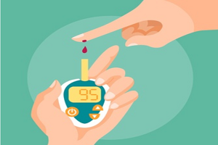

**2.Input Or parameters Page:-**

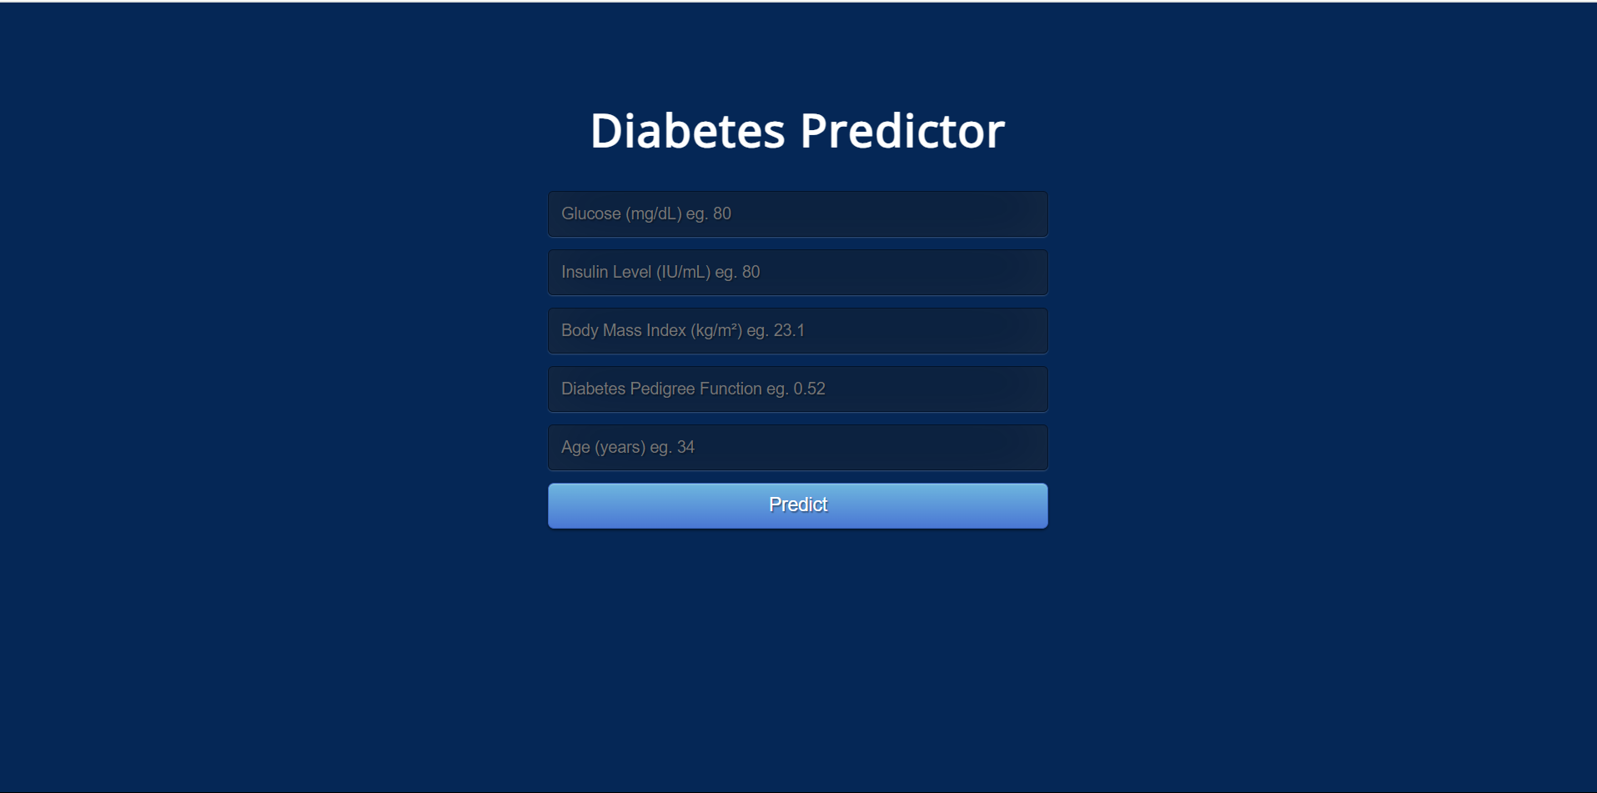

**3.Result Page**

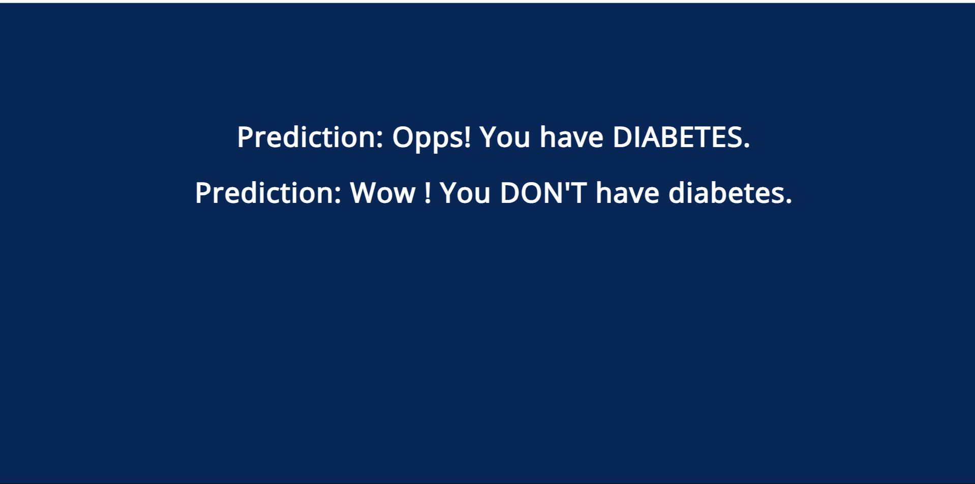

**7 CONCLUSION AND FUTURE SCOPES**

learning has the great ability to revolutionize the diabetes prediction with

the help of advanced computational methods.

• Detection of Diabetes in its early stage is the key for treatment.

• The technique may also help researchers to develop an accurate and efficient tool that will

reach at the table of clinicians to help them make better decisions about the disease.

• More parameters and factors would be involved in the future scope of this project.

• The accuracy will increase even more when the parameters increase Using traditional

techniques and algorithms, we can enhance the accuracy by improving the data

• Machine REFERENCE

* [Pima Indians Diabetes Database (kaggle.com)](https://www.kaggle.com/datasets/uciml/pima-indians-diabetes-database)
* [Diabetes Prediction using Machine Learning Algorithms - ScienceDirect](https://www.sciencedirect.com/science/article/pii/S1877050920300557)
* [Predicting Diabetes Mellitus With Machine Learning Techniques - PMC (nih.gov)](https://www.ncbi.nlm.nih.gov/pmc/articles/PMC6232260/#:~:text=With%20the%20rapid%20development%20of,It%20contains%2014%20attributes.)
* [(PDF) Diabetes Prediction using Machine Learning Algorithms (researchgate.net)](https://www.researchgate.net/publication/339543101_Diabetes_Prediction_using_Machine_Learning_Algorithms)

[1] Debadri Dutta, Debpriyo Paul, Parthajeet Ghosh, "Analyzing Feature

Importance’s for Diabetes Prediction using Machine Learning". IEEE, pp 942-

928, 2018.

[2] K.VijiyaKumar, Blavanya, Nirmala, S.Sofia Caroline, "Random Forest Algorithm

for the Prediction of Diabetes